SECTION 1 – KEY WORDS

Provide an A-Z of your urban futures. Some examples have been completed for you.

A | N
B | O
C | P
D | Q
E | RIO DE JANEIRO
F | R
G | S
H | S
I | T
J | U
K | U
L | W
MEGACITY | M

SECTION 2 – URBAN GROWTH RATES
Draw a line graph to show the growth of Shenzhen, a megacity in China (or create one in excel and paste below in the box)

Year | Population
1950 | 3,148
1995 | 2.39 million
2000 | 6.55 million
2025 | 12 million

- Describe the trend [quote stats from the graph/table]
- What problem did you find when drawing this graph?

SECTION 3 – CAUSES OF URBAN GROWTH

Using the push and pull factors on the following page, rank your factors for why economic migrants move from rural to urban Brazil.

Most important factor:

Least important factor:

Push and Pull Factors

Push | Pull
Lack of services. | Better paid jobs. (Factory workers receive about three times the wages of farm workers).
Pressure on the land, e.g. division of land among sons – each has too little to live on. | Houses that are more comfortable and a higher quality of life.
Limited food production due to overgrazing or the misuse of land, resulting in soil erosion or exhaustion. | A better chance of services, e.g. schools, medical treatment, entertainment.
Lack of employment opportunities. | The ‘bright lights’ of the city.
Many families do not own land. | Religious and political activities can be carried out more safely.
Starvation, resulting from either too little output for the people in the area or crop failure. Frequently, it may also be caused by a change in agriculture – from producing crops for the family/local community to a system that produces cash/plantation crops for consumption in MEDCs. | More reliable sources of food.
Overpopulation, resulting from high birth rates.
Extreme physical conditions, e.g. aridity, mountainous terrain, cold, heat and dense vegetation.
Mechanisation has led to a reduction in jobs available on the land, as well as a decrease in yields in many areas.
Lack of investment as money available to the government will be spent in urban areas.
Farming is hard work with long hours and little pay. In LEDCs, a shortage of money implies a lack of machinery, pesticides and fertiliser.
Local communities forced to move.

SECTION 4 – CONSEQUENCES OF URBAN GROWTH IN EDC CITIES

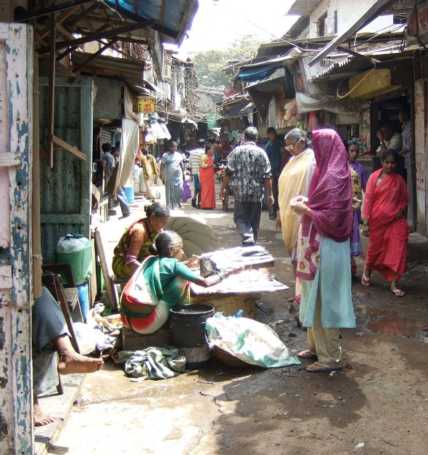
Study the photo and mind map the consequences. Remember consequences can be POSITIVE or NEGATIVE.

SECTION 5 – HUMAN TRENDS IN ADVANCED COUNTRIES - Find the following word
 |  | affordable |  |  |  |  |  | character |  |  |  |  | commuting |  |  |  |  |  | conflict |  |  |  |  | congestion
 |  | counterurbanisation |  |  |  |  |  | crime |  |  |  |  | decline |  |  |  |  |  | demography |  |  |  |  | deprivation
 |  | overcrowding |  |  |  |  |  | perception |  |  |  |  | pull |  |  |  |  |  | push |  |  |  |  | rural
 |  | schools |  |  |  |  |  | services |  |  |  |  | shops |  |  |  |  |  | transportation |  |  |  |  | urban
U | L |  | P | N | A | T | E |  | U | O | Y | M |  | N | N | O | S | H |  | O | P | S | R |  | Q
C | R |  | J | H | O | P | E |  | B | T | A | V |  | Q | T | V | B | L |  | T | W | C | F |  | C
W | O |  | B | M | C | I | K |  | Z | S | Y | N |  | O | Z | E | Y | I |  | O | S | R | H |  | F
U | R |  | M | A | X | W | T |  | E | P | O | A |  | D | Z | R | U | S |  | N | O | E | Z |  | Q
F | B |  | D | M | N | T | R |  | S | I | L | E |  | L | M | C | P | I |  | K | Z | H | W |  | S
D | P |  | Z | U | U | V | R |  | T | E | P | T |  | L | E | R | U | P |  | M | K | Q | C |  | Y
A | C |  | Q | L | I | T | P |  | A | R | G | S |  | M | M | O | L | G |  | Z | F | X | R |  | S
C | D |  | R | C | U | E | I |  | I | N | J | N |  | M | I | W | L | N |  | Z | Y | P | W |  | D
C | N |  | E | F | C | F | V |  | N | A | S | L |  | O | R | D | J | W |  | Y | C | P | M |  | E
K | S |  | C | R | P | A | C |  | W | G | I | P |  | H | C | I | N | Q |  | I | O | R | C |  | R
V | M |  | E | E | T | H | X |  | U | S | J | O |  | O | I | N | Z | M |  | L | N | A | Y |  | V
W | P |  | T | I | C | H | A |  | R | A | C | T |  | E | R | G | R | A |  | X | F | B | H |  | H
W | U |  | O | E | L | B | A |  | D | R | O | F |  | F | A | T | R | Z |  | P | L | V | P |  | M
E | N |  | I | L | C | E | D |  | T | J | K | B |  | I | R | U | A | U |  | M | I | Z | A |  | G
E | K |  | D | F | A | U | L |  | F | P | M | E |  | X | R | H | S | T |  | P | C | V | R |  | I
D | V |  | C | Y | F | A | F |  | R | Z | B | J |  | O | T | H | Y | M |  | I | T | F | G |  | U
Z | I |  | B | H | N | R | I |  | Y | S | W | N |  | J | R | O | F | F |  | P | O | T | O |  | Z
C | O |  | U | N | T | E | R |  | U | R | B | A |  | N | I | S | A | T |  | I | O | N | M |  | C
O | B |  | N | E | H | F | G |  | R | E | W | V |  | T | Q | M | V | R |  | U | A | S | E |  | W
E | N |  | K | C | L | X | B |  | H | X | U | W |  | R | O | R | S | S |  | S | I | R | D |  | J
Q | L |  | X | A | Q | R | X |  | M | I | S | S |  | N | D | X | S | B |  | A | V | L | O |  | P
Use the words from the wordsearch to complete the following two paragraphs:

is people migrating from areas to the countryside. This process has been occurring in large numbers since the 1960s.
Some factors include , high rates,
and pollution in the urban areas whereas factors include a of a better quality of life with more ……. …… housing in the
countryside. Better has meant that into the city is relatively easy.

Counterurbanisation can benefit areas by supporting such
as the local village and . However, it can also change the
of villages and cause between local residents and the incoming newcomers. Similarly, counterurbanisation can affect the inner city areas, which can into a spiral of .

- Define the single word from the word search not used in the paragraphs above.

SECTION 6 – URBAN FUTURES CASE STUDIES – comparison summary

Birmingham |  | Rio de Janeiro
 | Location
Population
size
 | Wealthy areas
 | Deprived areas
 | Housing differences
 | Sustainable solutions x4

